## **Preliminaries**

In addition to the base features we will be implementing in the course your group product must include additional features.

The base features of the product will include:

1. List notes
2. View a note
3. Create note
4. Edit a note
5. Comment on a note
6. Delete note
7. Delete comment
8. Register a user
9. User sign-in

Each group must identify 4 additional features to incorporate into their final project submission. Here are some examples to select from.

* Liking/favoriting notes and see a list that contains only those liked/favorited notes (Shortlisting)
* **Rating (5-star or thumbs up/down)**
* **Sorting (Alphabetical or Rate)**
* **Searching**
* Filtering (More than 3 stars or less than 60% thumbs down)
* Having a view counter (can be used to filter or to sort)
* Timestamp (Adding date to notes, it can be used to sort e.g., new to old or to filter e.g., since last week)
* User Privileges (Admin can see or approve some features e.g., editing a comment)
* Log all the actions taken by a user in a session (e.g., created a note, displayed a comment)
* Attaching an image to a note or comment
* Enforcing a regex to a field other than email
* Having an interactive shortcut menu that allows us to display a note or a comment quickly
* Adding a recommended notes
* **Customizing styles based on user preferences (e.g., user select theme (color, image, font..)**

After your team has finalized their selections include them in Part B section in your document overviewing your additional features.

## **Instructions**

Wireframing/LoFi (aka screen blueprint) is an important step in any user interface (UI) design process. While working in teams, wireframing helps us to rapidly prototype UIs and brainstorm about the feasibility of a UI design. This helps us to catch design issues much ahead of time, instead of programming and building a working prototype of the project and then fixing design issues.

With the abstractions provided by today’s high level languages, we are able to follow extremely fast development cycles like Agile and Extreme Programming (XP). This mentality forces us to immediately start writing code instead of stepping back and critically analyzing the technical components in our project which is really important to convey and ensure that the design decisions you have taken are good decisions.

Once the team is in consensus about the goals and design decisions made, it is easy to split the tasks and keep track of the different tasks using one of the task management tools currently available on the market. This is why we need a design document for any project that involves group decisions for attaining clarity.

**Note:** An example for parts II can be found at this link:

<https://docs.google.com/document/d/19MJpGIeRSI4AWcL99ySTNP2jx61pxAMY9xoMslt6rSs/edit?usp=sharing>

[(Links to an external site.)](https://docs.google.com/document/d/19MJpGIeRSI4AWcL99ySTNP2jx61pxAMY9xoMslt6rSs/edit?usp=sharing)

### Part A (10 points):

Add the below information to your project document.

1. What are some ethical considerations of your product?

Ethical considerations of our product include enlisting login credential protocols to emphasize on security and privacy and the protection of users’ data, allowing a user to modify or delete their notes or property, utilizing html validation within our code to ensure input accuracy, and formatting our application favorably to our low-vision users.

2. Address any features in your product that could be misused and how you plan to guard against misuse. *For example, if you plan to allow images to be uploaded by users, will you include a way for other users to report inappropriate images or use some other strategy?*

We will only allow users to email a maximum of two notes back and forth each in hopes of preventing this application to become a mode to communicate or “pass notes” electronically as this is not part of the purpose behind the creation of this application. We will implement a time duration of ten minutes between every time a user sends two notes to another user within a five minute period.

### Part B (10 points):

1. List all the features you plan on including in your project. Include the baseline features and your group-selected additional features.

Baseline Features

1.List notes

2.View a note

3.Create note

4.Edit a note

5.Comment on a note

6.Delete note

7.Delete comment

8.Register a user

9.User sign-in

Additional Features

10.Rating (5-star or thumbs up/down)

11.Sorting (Alphabetical or Rate)

12.Searching

13.Customizing styles based on user preferences (e.g., user select theme (color, image, font..)

2. As a group decide on a tool (e.g, google slides, powerpoint, moqups.com, **draw.io**, justinmind.com,...) to use for creating mockup prototypes of the user interfaces.

* Using Draw.io

2. Design the pages for your app as Lo-Fi UIs using any tool. At a minimum your pages should include include:

* + **The main app page**
  + **A page that displays the list of notes stored in your database**
  + **A page that displays a note and its comments**
  + **A page with a form to input data for a note**
  + **A page with a form to edit data for a note**
  + **A page with a form to input data for a comment**
  + **A page with a user registration**
  + **A page with a user sign in (login)**

3. Create a storyboard with your pages by adding arrows from one page to another to show the path from one page to another. **Note:** Google slides will allow you to paste images and then draw arrows and other images.

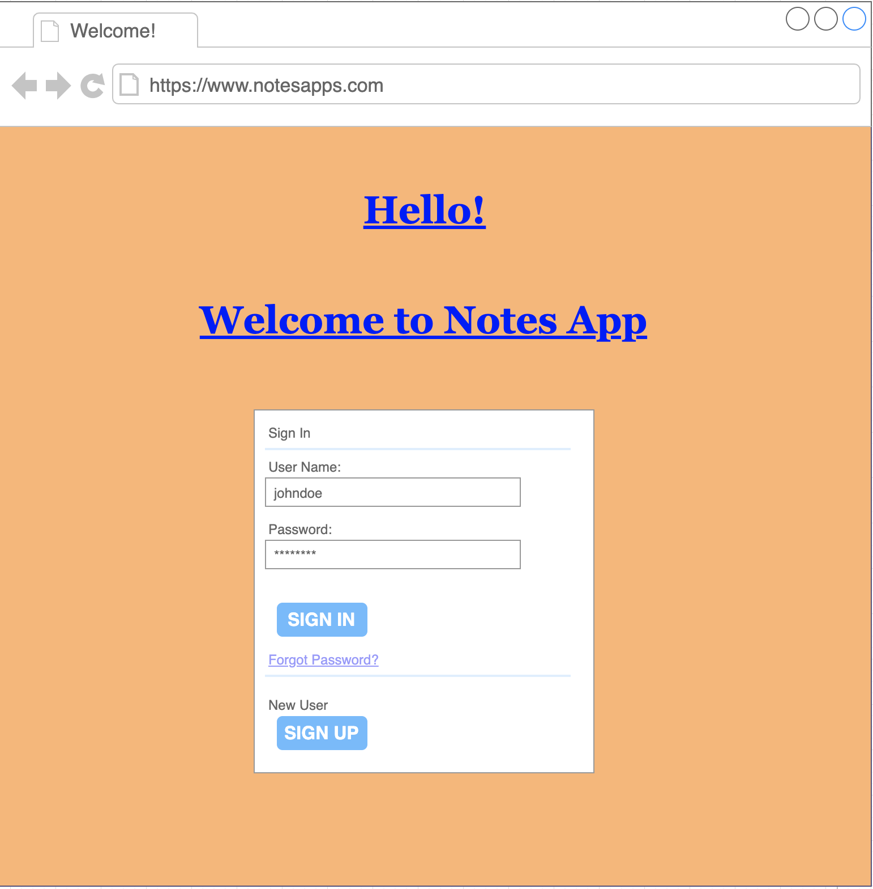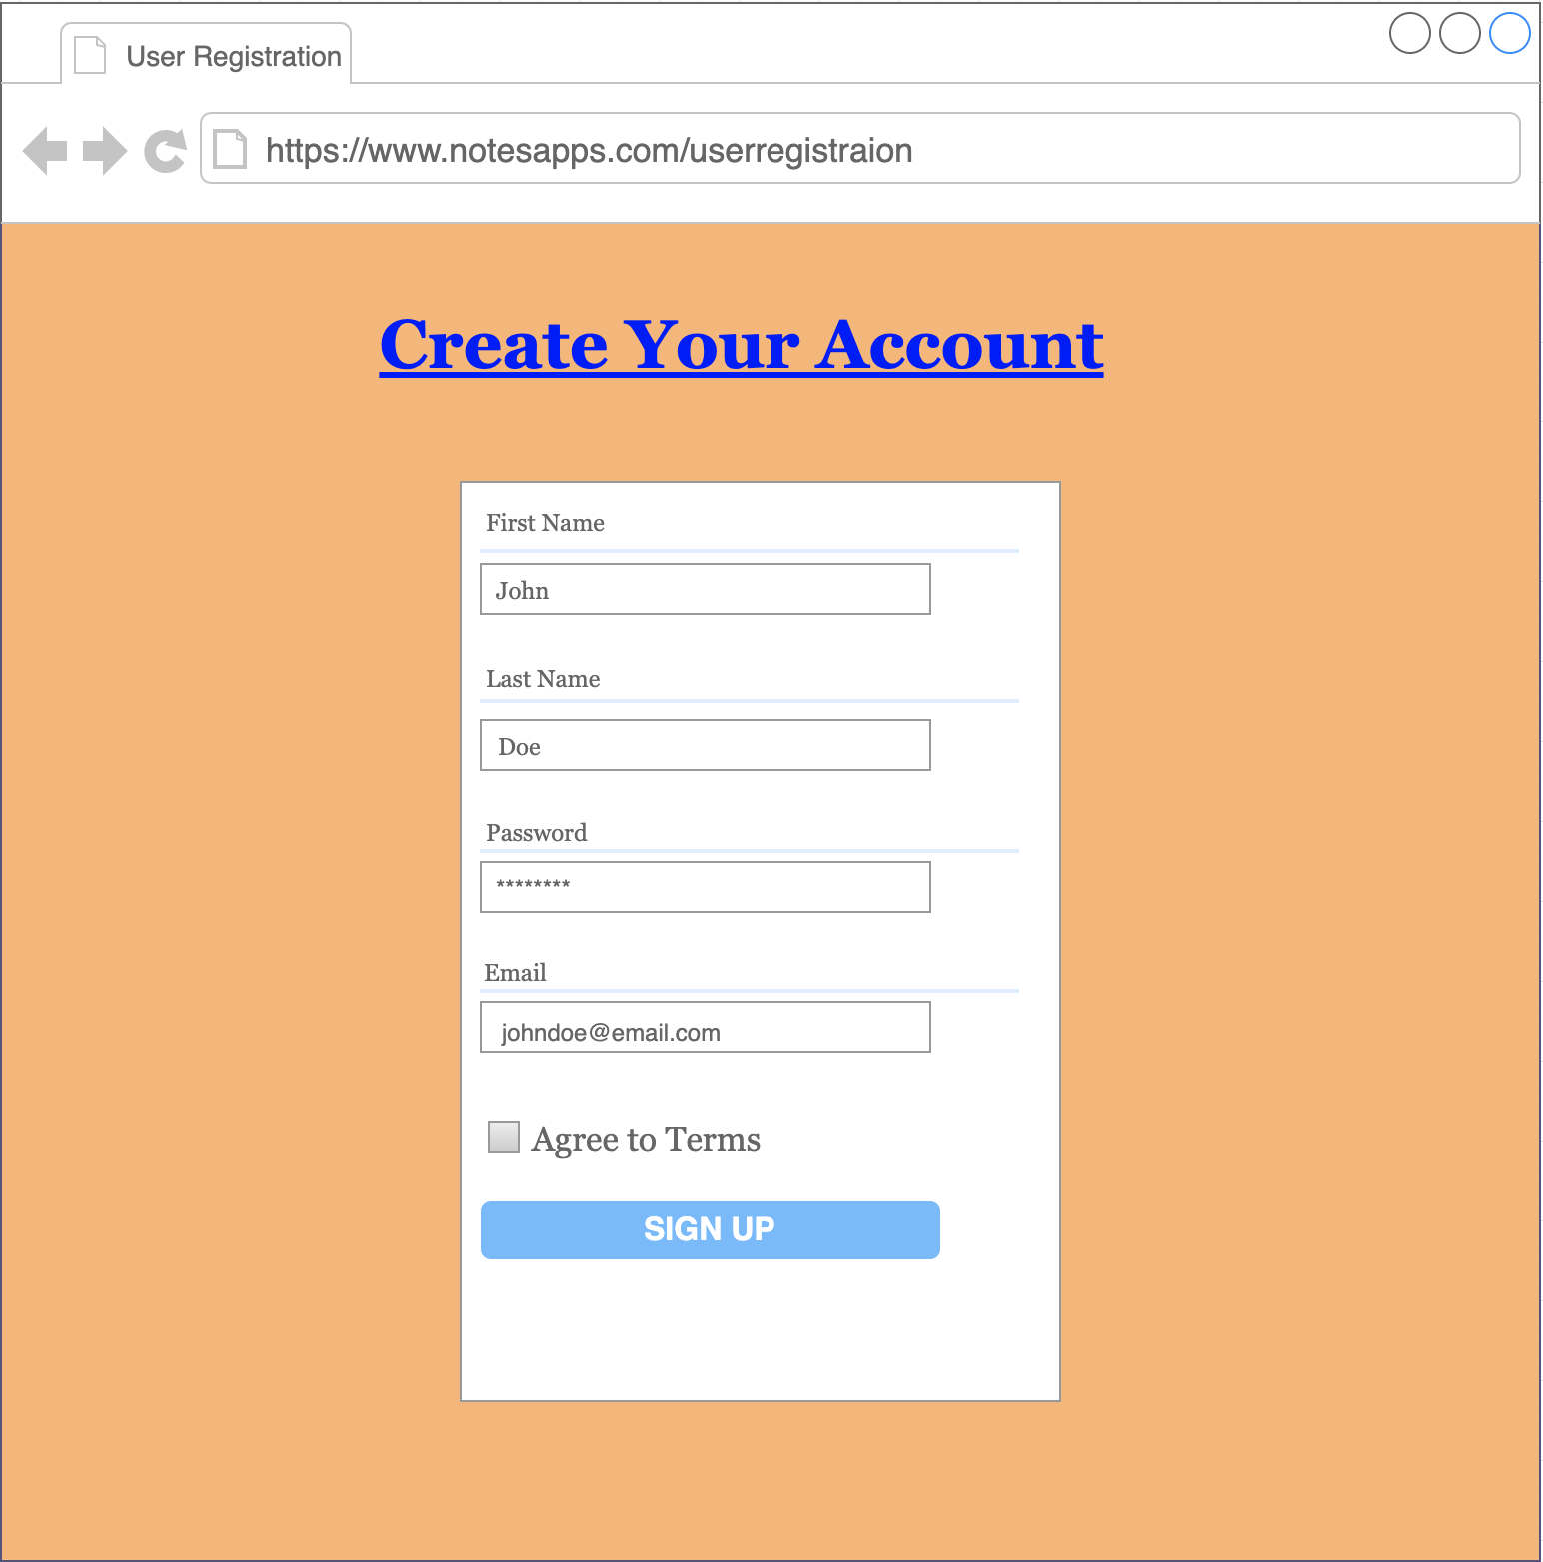

## 

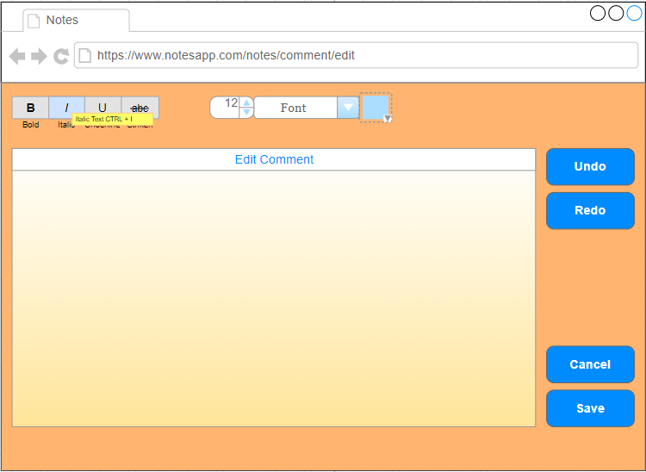

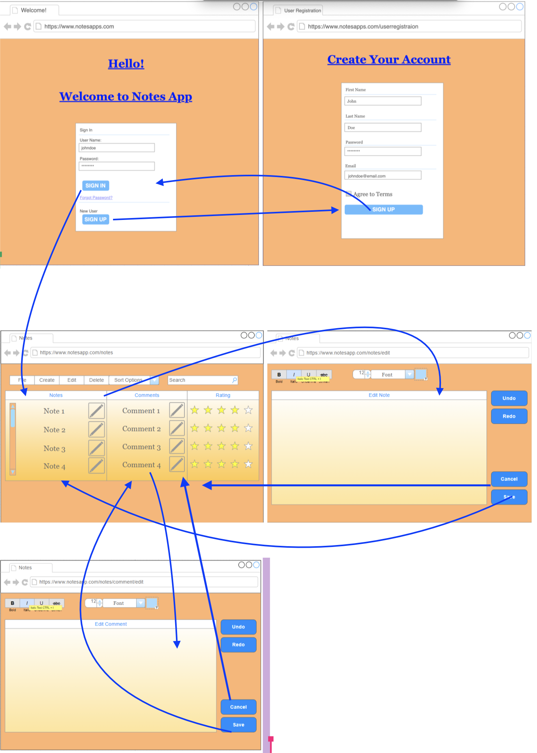

## 

## **Submission**

Export your Google document as a PDF and have ONE member of your group submit it to this assignment.